ASCOM PowerStatus Safety Monitor

This driver will check the SystemInformation.PowerStatus class and use the results to set the ASCOM IsSafe property. This will work with a laptop which has its own internal backup battery. It doesn’t seem to work with a UPS because these seem to use their own, possibly UPS specific, power management system.

Installation
Run the PowerStatusSetup.exe installer. This uses the normal ASCOM installation process. This file is shown if required.

Setup
This shows the PowerStatus setup dialog:
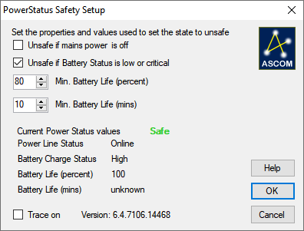

Set the properties as required:
- If Unsafe if mains power is off is checked then if the Power Line Status reports Offline then IsSafe is reported as true , i.e. unsafe.
- If Unsafe if Battery Status is Low or Critical is checked then IsSafe will be reported as True if the Battery Charge Status reports Low or Critical.
- If Min Battery life (percent) is less than Battery Life (percent) then IsSafe will be reported as true. Set Min battery Life (percent) to 0 to disable this check
- If Min Battery Life (mins) is less than Battery Life (mins) then IsSafe is reported as safe (true). Set this to 0 to disable this check.
- Check the Trace On button to enable trace logging. The log file is named ASCOM.PowerStatus.<time>.<nnn>.txt and is in the folder Documents\ASCOM\Logs <date>\.
- Click on Cancel to exit without saving the changes.
- Click on OK to save the current settings and close the dialog.
- Click on Help to show this help file.

The current Power Status is monitored while the setup dialog is open and the relevant states are shown. The safety state the current power status and settings will give is shown as Safe or Unsafe.

The setup Dialog can be opened while the driver is connected and the values can be changed. The effect of the change will be shown in the dialog immediately but will only apply to the application when the OK button is pressed.

Notes:
- Setting Unsafe if mains power is off may make a system a little too sensitive to a short power failure so it may be better to leave this unchecked and use the two minimum battery life measures as the primary checks.
- Set the Min Battery Life (mins) to significantly longer than it will take to close everything down completely and the Min Battery Life (percent) to a value that prevents excessive shut downs in response to short power failures.
- Unsafe if Battery Status is low or critical should always be checked, A system that gets into this state will be about to close down anyway.
- Make sure that the Windows power states are set so that the laptop will continue running for long enough that the system won’t be closed before the application has completed it shutdown process.

Operation
This is intended to signal to an application that the power is failing and so allow the application to close down in an orderly manner while there is still backup power available.

A typical installation would be running on a laptop, with the laptop powered directly from the mains. All other systems, scope, cameras, observatory roof etc. would be powered from a UPS or perhaps from a battery with a float charger. When the mains power fails the Power Status monitor signals this and the application performs an orderly close down, warming the camera, parking the scope, parking the dome, closing the roof/shutter and if possible shutting down power to everything. It may be reasonable to leave the laptop to it’s own close process.

Unfortunately UPSs don’t seem to use the PowerStatus directly so it doesn’t seem to work with them. One way to use this for a system running on a UPS would be to have a separate laptop with this PowerStatus monitor which used ASCOM Remote to report the safety state to the UPS backed up system. The laptop would be powered directly from the mains and so would signal when the power had failed.

Bear in mind that this is no more reliable than the Windows Pc running this and any other applications. If the PC crashes, or the application monitoring this safety information stops working then it is likely that no safety actions will be done.

If safety is critical to your system, and especially if a failure will damage your equipment, then you are strongly recommended to have a system to render your observatory safe that is independent of the application and of any complex computing system.
For example, use a simple relay based shutter or roof close system, with an independent power supply, arranged so that if a signal stops the shutter/roof will close.
Have as simple an emergency close process as possible. Try to avoid having a shutter/roof system that requires that the mount is parked in a particular position before it is closed.

